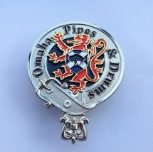
OP&D Cap Badge
Order Form
Date Ordered: Click here to enter a date.

ORDERED BY: SHIP TO (if different than ordered by):
[Name] [Name]
[Street Address] [Street Address]
[City, ST ZIP Code] [City, ST ZIP Code]
[Phone] [Phone]

Qty | Description | Price ea. | TOTAL
[#] | Omaha Pipes and Drums Cap Badge | $10.00 | [total]
TOTAL | Shipping and handling |  | FREE
[#] | Total enclosed |  | [total]

MAKE CHECKS PAYABLE TO:
Omaha Pipes and Drums, Inc.

MAIL PAYMENT AND COMPLETED ORDER TO:
Pete Heineman
2020 Avenue B
Council Bluffs, IA 51501

OFFICE USE ONLY

ORDER NUMBER:
DATE RECEIVED:
DATE FILLED/MAILED:

NOTES:

